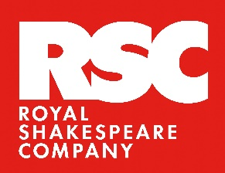
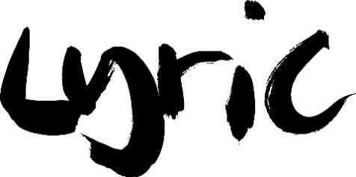
Press Release
Monday 11 September 2023
DOWNLOAD IMAGES
T: @LyricHammer | I: /LyricHammersmith | F: /LyricHammersmith

THE ROYAL SHAKESPEARE COMPANY’S THE EMPRESS TRANSFERS TO THE LYRIC HAMMERSMITH THEATRE
THIS AUTUMN
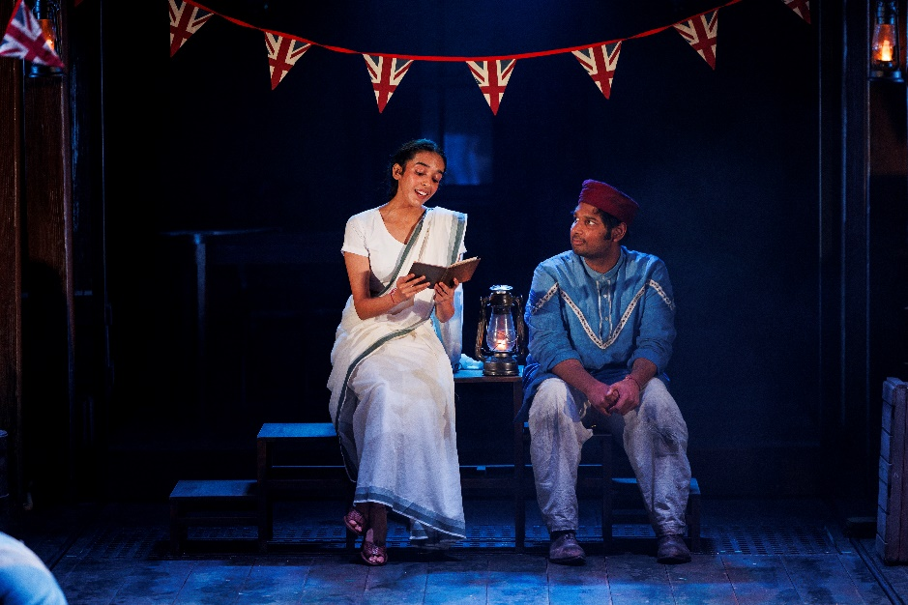

- THE LYRIC’S ARTISTIC ASSOCIATE, TANIKA GUPTA, RETURNS WITH THE EMPRESS, FOLLOWING HER ACCLAIMED ADAPTATION OF HENRIK IBSEN’S A DOLL’S HOUSE AT THE LYRIC HAMMERSMITH THEATRE IN RACHEL O’RIORDAN’S DEBUT SEASON.

- DIRECTED BY POOJA GHAI, ARTISTIC DIRECTOR OF TAMASHA THEATRE COMPANY, THE EMPRESS OFFERS A FRESH PERSPECTIVE ON BRITAIN’S RELATIONSHIP WITH ITS IMPERIAL PAST.
- THE EMPRESS TRANSFERS TO THE LYRIC HAMMERSMITH THEATRE ON 04 OCTOBER AND ENDS 28 OCTOBER. TICKETS ON SALE NOW WWW.LYRIC.CO.UK

★★★★★ ‘ABSOLUTELY FLAWLESS’ West End Best Friend
★★★★ ‘OUTSTANDING’ Guardian
★★★★ ‘A VICTORIAN DOUBLE ROMANCE WITH CINEMATIC SWEEP’ The Times
★★★★ ‘A CELEBRATION OF CULTURE AND STRENGTH’ Birmingham Mail

Lyric Hammersmith Theatre presents the Royal Shakespeare Company production of
The Empress
Written by Tanika Gupta
Directed by Pooja Ghai
Wednesday 04 - Saturday 28 October 2023
Press Night: Tuesday 10 October 2023

This autumn the Royal Shakespeare Company brings their acclaimed play The Empress by Lyric Hammersmith Theatre Artistic Associate Tanika Gupta to the Lyric for four weeks only from 4 October.

Transferring directly from the Swan Theatre in Stratford-upon-Avon and directed by Pooja Ghai, Artistic Director of Tamasha, this new production of The Empress takes you from the rugged gangways of Tilbury docks to the grandeur of Queen Victoria’s Palace, whilst unveiling the long and embedded culture of British Asian history.

The Empress was written by Tanika Gupta. The production is directed by Pooja Ghai with Design by Rosa Maggiora. Lighting is by Matt Haskins, Music and Sound by Ben and Max Ringham, Movement by Wayne Parsons, Dramaturgy by Pippa Hill, Fights and Intimacy by Rachel Bown-Williams and Ruth Cooper-Brown, and Casting by Matthew Dewsbury CDG and Martin Poile.

Rachel O’Riordan, Artistic Director of the Lyric Hammersmith Theatre said: “We’re so excited to be welcoming the Royal Shakespeare Company’s production of The Empress by our very own Artistic Associate, Tanika Gupta and directed by Pooja Ghai. This is an exciting time for West London, we are so pleased to host the RSC here in Hammersmith for this sweeping story through British Indian history.”
The Empress is another impressive play in Tanika Gupta’s ever growing canon of work. Tanika’s acclaimed adaptation of Ibsen’s A Doll’s House opened my first season here at the Lyric in 2019. We are honoured to be the London home of this epic production that unveils the long and embedded culture of British Asian history in nineteenth century Britain and we cannot wait for audiences to see this story come to life in our beautiful Victorian Frank Matcham Theatre.”
Spanning 13 years over the ‘Golden Era’ of Empire, this story blends the experiences of Indian ayahs (nursemaids) and lascars (sailors) who worked on the ships carrying trade goods, alongside the first Indian politician to be elected as a Member of Parliament.
It is 1887, the year Queen Victoria celebrates her Golden Jubilee.
Sixteen year old Rani Das, ayah (nursemaid) to an English family arrives at Tilbury docks after a long voyage from India, to start a new life in Britain. On the boat, Rani befriends a lascar (sailor), Dadabhai Naoroji, an Indian politician, and Abdul Karim, a royal servant destined to serve the Queen. Full of hopes and dreams of what lies ahead, they each embark on an extraordinary journey.
Will their expectations come true or will they have to forge a different path in their new country?
Tanya Katyal plays Rani Das. Her theatre credits include When Mountains Meet at Cottiers Theatre, Glasgow. Television credits include Netflix’s Eternally Confused and Eager for Love.

Raj Bajaj plays Abdul Karim. Raj’s previous RSC credits include Tamburlaine, Tartuffe and Much Ado About Nothing. Other recent theatre credits include Wildfire Road (Sheffield Crucible), Tartuffe (Birmingham Rep), Hobson's Choice (Royal Exchange Manchester), Rapunzel (Stratford East), Lions & Tigers, The Merchant of Venice (Shakespeare’s Globe), East is East (Northern Stage/Nottingham Playhouse) and Bend It Like Beckham (Phoenix Theatre).

Alexandra Gilbreath plays Queen Victoria. She is an Associate Artist of the Royal Shakespeare Company, where her credits include; The Provoked Wife, The Rover, Shakespeare Live!, A Midsummer Night’s Dreaming, The Merry Wives of Windsor, Twelfth Night for which she received an Olivier award nomination-for Best Supporting Actress, Merry Wives – The Musical, The Taming of the Shrew, The Tamer Tamed, As You Like It, Romeo and Juliet, The Winter’s Tale, Cyrano de Bergerac, Ghosts, The Country Wife, Love’s Labour’s Lost. Other theatre includes; The Sugar Syndrome at the Orange Tree; The Fever Syndrome, Mother Christmas at Hampstead Theatre Downstairs; The Lie at Menier Chocolate Factory; Dessert at Southwark Playhouse; The Wars of the Roses, Hayfever at the Rose Kingston; The Invisibles at the Bush; A Midsummer Night’s Dream for Hong Kong Philharmonic; The Village Bike, Disappeared at the Royal Court; Shallow Slumber, God’s Dice at Soho Theatre; Othello at Sheffield Crucible; and Playhouse Creatures at Chichester Festival Theatre.
Screen credits include; Becoming Elizabeth, EastEnders, Father Brown, Casualty, WPC56, In Search of Shakespeare, Rites of Passage, Inspector George Gently, The Commander, The Waltz King, Happiness, The Project, Trial and Retribution, Midsomer Murders, Absolute Power, Life Begins, The Bill, Monarch of the Glen, Out of Hours, A Wing and a Prayer, The Art of Love, Lair, Warhol, Dead Babies, The All Together, A Hundred Streets and Tulip Fever.

Completing the company are: Francesca Faridany (Lady Sarah), Aaron Gill (Hari), Anyebe Godwin (Serang/Lascar), Miriam Grace Edwards (Charlotte/Susan), Oliver Hembrough (Lord John Oakham/William/Painter), Avita Jay (Firoza), Tom Milligan (Freddie/Ensemble), Sarah Moyle (Mary/Susan Matthews), Chris Nayak (Jinnah/Singh), Lauren Patel (Ruby/Asha), Simon Rivers (Dadabhai Naoroji), Anish Roy (Gandhi/Lascar), Nicola Stephenson (Lascar Sally), Premi Tamang (Lascar/Ayah), and Joe Usher (Lascar).

Tanika Gupta has written over 25 stage plays that have been produced in major theatres across the UK. Her critically acclaimed adaptation of Ibsen’s A Doll’s House set in colonial Calcutta launched Rachel O’Riordan’s first season as Artistic Director of the Lyric in 2019. She was awarded an MBE for Services to Drama and is a Fellow of the Royal Society of Literature. She is an Artistic Associate at the Lyric and was recently announced as one of two new Writers in Residence at the Bush Theatre in 2023.

Pooja Ghai is Artistic Director of Tamasha, and artistic associate at Kali. Prior to this she was Associate Director at Theatre Royal Stratford East. Her most recent directing credits include Hakawatis and Lions and Tigers at the Sam Wanamaker Playhouse; Lotus Beauty at Hampstead Theatre; Seriously Annoying by Mark Thomas for Tin Cat Productions, 2020 at Tara Theatre, Approaching Empty at the Kiln (Tamasha/Kiln/Live Theatre) and Rapunzel, Counting Stars and House of in Between at Theatre Royal Stratford East. Awards include Best Director for Lions and Tigers at the Eastern Eye Arts, Culture and Theatre Awards (ACTA) in 2017. Pooja is a Dramaturg for Voxed, Meeting, Out Late, Vestige and It’s Not Me.

The play-text was recently added to the GCSE drama syllabus following a campaign aided by participation from the RSC's Youth Advisory Board and is now one of four new plays by writers of the global majority to better reflect the diversity of playwriting in the UK. The text was introduced by AQA in 2022, the largest examination board in England. Tanika’s 2019 production of A Doll’s House was previously added to the national curriculum by Pearson in 2021 alongside works by Bola Agbaje, In-Sook Chappell and Roy Williams.

YOUNG LYRIC
In response to The Empress, Young Lyric will create a series of teacher CPD sessions for secondary schools across West London which examines Gupta’s text and curriculum links. The production will be accompanied with a complimentary teachers guide exploring The Empress as a set text on the AQA Drama curriculum, this guide will be created in collaboration with RSC Education.

- ENDS -
Burte Tsogbadrakh / 020 8741 6822 / burte.tsogbadrakh@lyric.co.uk



Notes to Editors
IMAGES available to download here
TRAILER available to download here

Listings
Lyric Hammersmith Theatre
Lyric Square, King Street, London, W6 0QL
Box office: 020 8741 6850
www.lyric.co.uk
Tickets from £10

About the Lyric Hammersmith Theatre
The Lyric Hammersmith Theatre produces bold and relevant world-class theatre from the heart of Hammersmith, the theatre’s home for more than 125 years. Under the leadership of Artistic Director and CEO Rachel O’Riordan, it is committed to being vital to, and representative of, the local community. A major force in London and UK theatre, the Lyric produces adventurous and acclaimed theatrical work that tells the stories that matter. The Lyric Hammersmith Theatre has a national reputation for ground-breaking work to develop and nurture the next generation of talent, providing opportunities for young people to discover the power of creativity and to experience the life changing impact of theatre. We are the creative heart of Hammersmith, proud of our history and ambitious for our future.
About Royal Shakespeare Company (RSC)
The Royal Shakespeare Company is a theatre and learning charity that creates world class theatre, made in Stratford-upon-Avon and shared around the world, performing plays by Shakespeare and his contemporaries, as well as commissioning an exceptionally wide range of original work from contemporary writers. Our purpose is to ensure that Shakespeare is for everyone, and we do that by unlocking the power of his plays and of live performance and our learning and education work throughout the UK and across the world.

We believe everybody’s life is enriched by culture and creativity. We have trained generations of the very best theatre makers and we continue to nurture the talent of the future. Our transformative Learning programmes reach over half a million young people and adults each year, and through our Creative Placemaking and Public Programme we create projects with and for communities who have not historically engaged with our work. We are a leader in creative immersive technologies and digital development.

We have a proud record of innovation, diversity and excellence on stage and are determined to grasp the opportunity to become an even more inclusive, progressive, relevant and ambitious organisation.

We have one of the UK’s largest arts learning programmes, working with over 1,000 schools each year to broaden access to high quality arts learning and transform experiences of Shakespeare in schools. Through our national partnership programme with schools and regional theatres we target areas of structural disadvantage, including 26 areas of multiple deprivation across the country, from Cornwall to Middlesbrough. Research shows that our approaches to teaching Shakespeare support the development of reading and writing skills, accelerate language acquisition and development, raise aspirations and improve student attitudes to school and learning in general. They also foster well-being, self-esteem, empathy, resilience and tolerance and promote critical-thinking, creative, analytical, communication and problem-solving skills.

We are committed to being a teaching and learning theatre and we are the only arts organisation to have been awarded Independent Research Organisation status. We create world class theatre for, with and by audiences and theatre makers of all ages. We provide training for emerging and established theatre makers and arts professionals, for teachers and for young people. We share learning formally and informally. We embed training and research across our company, work and processes.

We recognise the climate emergency and work hard to embed environmental sustainability into our operations, creative work and business practice, making a commitment to continually reduce our carbon footprint.
All of this work is only possible with the ongoing generosity of our supporters. Please donate at rsc.org.uk/donate

Arts Council England is the national development body for arts and culture across England, working to enrich people’s lives. We support a range of activities across the arts, museums and libraries – from theatre to visual art, reading to dance, music to literature, and crafts to collections. Great art and culture inspires us, brings us together and teaches us about ourselves and the world around us. In short, it makes life better. Between 2018 and 2022, we will invest £1.45 billion of public money from government and an estimated £860 million from the National Lottery to help create these experiences for as many people as possible across the country.www.artscouncil.org.uk

LISTINGS
A Royal Shakespeare Company production
The Empress
By Tanika Gupta
Directed by Pooja Ghai
Design by Rosa Maggiora
Lighting by Matt Haskins
Music and Sound by Ben and Max Ringham
Movement by Wayne Parsons
Dramaturgy by Pippa Hill
Fights and Intimacy by Rachel Bown-Williams and Ruth Cooper-Brown
Casting by Matthew Dewsbury CDG and Martin Poile
Dates: Wednesday 04 – Saturday 28 October 2023
Press Night: Tuesday 10 October 2023, 7pm
Audio Described Performance: Tuesday 17 October, 7.30pm
Chilled Environment Performance: Wednesday 18 October, 1.30pm
Open Captioned Performance: Friday 20 October, 7.30pm
Integrated BSL Performance: Friday 27 October, 7.30pm
Swan Theatre Stratford-upon-Avon dates: Friday 7 July- Saturday 18 November

